Java Assessment

1. Write a Java Program to iterate HashMap using While and advance for loop.
Code : -
// Write a Java Program to iterate HashMap using While and advance for loop.
package com.company;
import java.util.Iterator;
import java.util.HashMap;
class HashMapIteration{
private HashMap<Integer, String> hm = new HashMap<Integer, String>();
private HashMap<String,String> map = new HashMap<String,String>();
public void usingWhileLoop(){
hm.put(11,"Ravi");
hm.put(12,"Prateek");
hm.put(13, "Davesh");
hm.put(14, "Kamal");
hm.put(15, "Pawan");
Iterator <Integer> it = hm.keySet().iterator(); //keyset is a method
while(it.hasNext())
{
int key=(int)it.next();
System.out.println("Roll no.: "+key+" name: "+hm.get(key));
}
}
public void usingAdvanceForLoop(){
map.put("TCS","$100 billion");
map.put("Wipro","$21.5 billion");
//iteration over map using forEach() method
map.forEach((k,v) -> System.out.println("Company: " + k + ", Net worth: "+ v));
}
}
public class question1 {
public static void main(String[] arg)
{
HashMapIteration hmi = new HashMapIteration();
System.out.println("HashMap iteration using while loop :");
hmi.usingWhileLoop();
System.out.println("\nHashMap iteration using advanced for loop (for each loop) :");
hmi.usingAdvanceForLoop();
}
}

Output : -
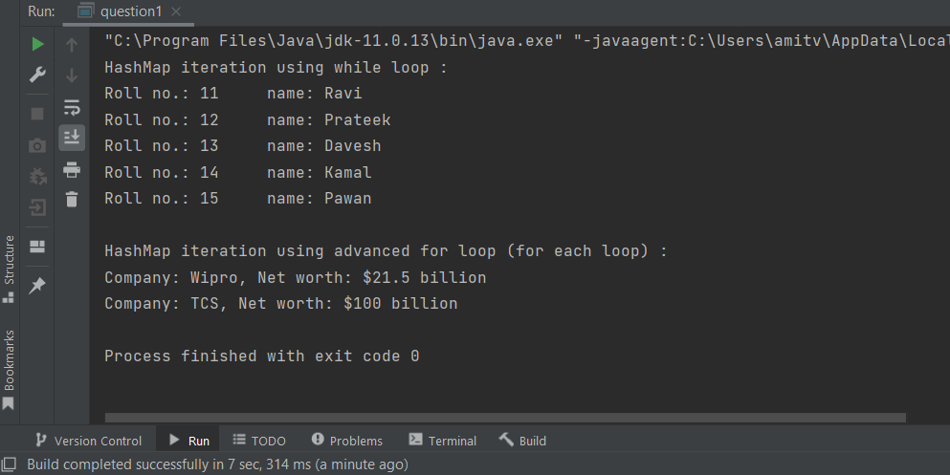

2. Write A Java Program to count the number of duplicate words in a string using HashMap
Code : -
// Write A Java Program to count the number of duplicate words in a string using HashMap
package com.company;
import java.util.HashMap;
public class question2 {
public static void main(String[] args) {
String str = "Write a Java Program to count the number of words in a string using HashMap";
HashMap<String, Integer> hashMap = new HashMap<>();
String[] words = str.split(" ");
for (String word : words) {
// Asking whether the HashMap contains the key or not. Will return null if not.
Integer integer = hashMap.get(word);
if (integer == null)
// Storing the word as key and its occurrence as value in the HashMap.
hashMap.put(word, 1);
else {
// Incrementing the value if the word is already present in the HashMap.
hashMap.put(word, integer + 1);
}
}
System.out.println(hashMap);
}
}

Output : -
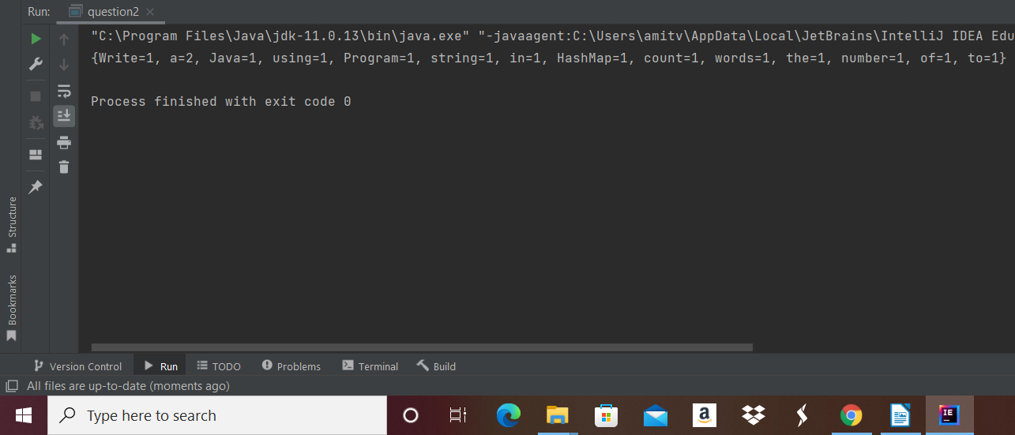

3. Write Java Program to iterate ArrayList using for-loop, while-loop, and advance for-loop.
Code : -
// Write Java Program to iterate ArrayList using for-loop, while-loop, and advance for-loop.
package com.company;
import java.util.*;
class ArrayListIteration {
List<Integer> numbers = Arrays.asList(1, 2, 3, 4, 5, 6, 7, 8);
public void usingForLoop() {
System.out.println("Iterating ArrayList using For Loop :");
for (int i = 0; i < numbers.size(); i++)
// Printing and display the elements in ArrayList
System.out.print(numbers.get(i) + " ");
}
public void usingWhileLoop() {
System.out.println("\n\nIterating ArrayList using While Loop :");
int val = 0;
while (numbers.size() > val) {
System.out.print(numbers.get(val) + " ");
val++ ;
}
}
public void usingAdvanceForLoop() {
System.out.println("\n\nIterating ArrayList using Advance For Loop (ForEach Loop) :");
for(int i:numbers) System.out.print(i+" ");
}
}
public class question3 {
public static void main(String[] args) {
ArrayListIteration ali = new ArrayListIteration();
ali.usingForLoop();
ali.usingWhileLoop();
ali.usingAdvanceForLoop();
}
}

Output : -
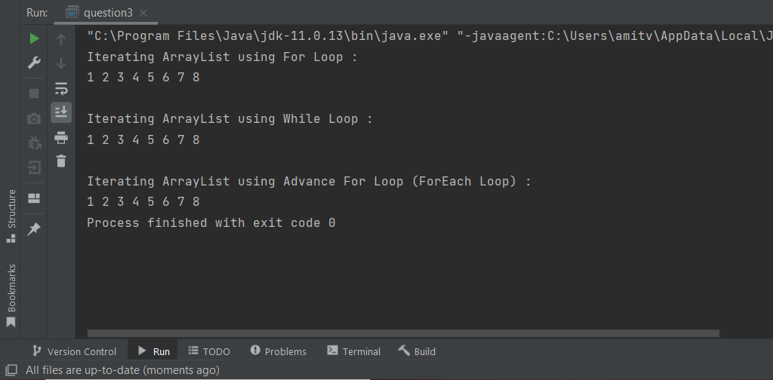

4. Write a Java Program to find the duplicate characters in a string.
Code : -
// Write a Java Program to find the duplicate characters in a string.
package com.company;
public class question4 {
public static void main(String[] args) {
String str = "Hello world";
int count;
//Converts given string into character array
char[] str1 = str.toCharArray();
System.out.print("Duplicate characters in a given string '"+str+"' are : ");
//Counts each character present in the string
for(int i = 0; i <str1.length; i++) {
count = 1;
for(int j = i+1; j <str1.length; j++) {
if(str1[i] == str1[j] && str1[i] != ' ') {
count++;
//Set string1[j] to 0 to avoid printing visited character
str1[j] = '0';
}
}
//A character is considered as duplicate if count is greater than 1
if(count > 1 && str1[i] != '0')
System.out.print(str1[i]+" ");
}
}
}

Output : -
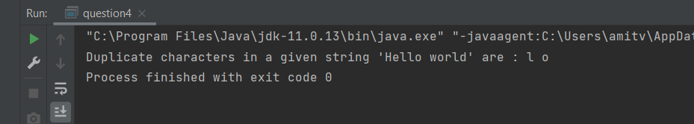

5. Write a Java Program to find the second-highest number in an array.
Code : -
// Write a Java Program to find the second-highest number in an array.
package com.company;
import java.util.*;
public class question5 {
public static int getSecondLargest(Integer[] x, int total){
List<Integer> list=Arrays.asList(x);
Collections.sort(list);
int element=list.get(total-2);
return element;
}
public static void main(String args[]){
Integer a[]={8,6,5,2,0};
System.out.println("Second highest number in given array is : "+getSecondLargest(a,a.length));
}
}

Output : -
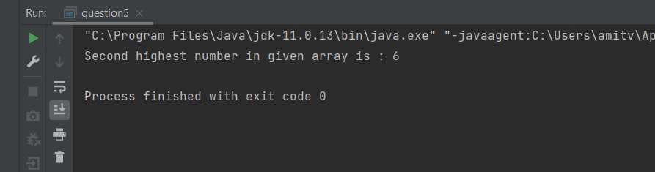

6. Given a String, find the first repeated character in it using Stream functions.
Code : -
// Given a String, find the first repeated character in it using Stream functions.
package com.company;
import java.util.LinkedHashMap;
import java.util.Map;
import java.util.Optional;
import java.util.function.Function;
import java.util.stream.Collectors;
public class question6 {
public static void main(String[] args) {
String str = "Hello world";
System.out.println("Entered string is '"+str+"'");
Map<Character, Long> collect = str.chars()
.mapToObj(i -> (char)i)
.collect(Collectors.groupingBy(Function.identity(), LinkedHashMap::new, Collectors.counting()));
Optional<Character> firstRepeat = collect.entrySet()
.stream().
filter( (e) -> e.getValue() > 1).
map(e -> e.getKey()).findFirst();
System.out.println("The first repeated character in given string is '" + firstRepeat.orElse(null)+"'");
}
}

Output : -
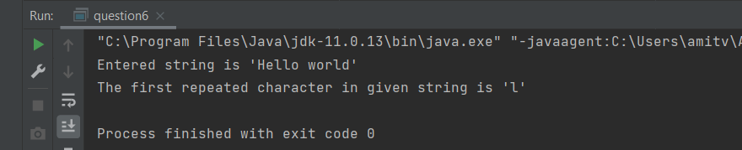

7. Given a String, find the first non-repeated character in it using Stream functions.
Code : -
// Given a String, find the first non-repeated character in it using Stream functions.
package com.company;
import java.util.LinkedHashMap;
import java.util.Map;
import java.util.Optional;
import java.util.function.Function;
import java.util.stream.Collectors;
public class question7 {
public static void main(String[] args) {
String str = "Hello world";
System.out.println("Entered string is '"+str+"'");
Map<Character, Long> collect = str.chars()
.mapToObj(i -> (char)i)
.collect(Collectors.groupingBy(Function.identity(), LinkedHashMap::new, Collectors.counting()));
Optional<Character> firstNonRepeat = collect.entrySet()
.stream()
.filter( (e) -> e.getValue() == 1)
.map(e -> e.getKey()).findFirst();
System.out.println("The first non-repeated character in given string is '" + firstNonRepeat.orElse(null)+"'");
}
}

Output : -
